Dear Trip Applicant,

The Edna Karr College Room is proud to present you with the opportunity to go to Jackson, Chicago, St. Louis, and Nashville for this year’s Spring Break College Trip!

We’re going to take around 40 students (mostly sophomores and juniors and a few freshman). The purpose of this trip is to expose promising students to great schools. We will have fun, but this trip comes with a lot of serious duties. We will be looking for students who demonstrate the following qualities:

- Strong academics and work ethics
- A desire to challenge oneself
- A curiosity for college options outside of Louisiana.

We will judge applications holistically. No part of the application outweighs the other and no part of the application will get you accepted or rejected to the trip. It is important that you turn in every part of the application!

Here are the required parts of the application:

- Online Application Form: http://bit.ly/EKSpringBreak15 (case sensitive)
- Hardcopy of the essays
- Teacher Evaluation (2)
- Parent Consent

These are all due to Ms. Lu by November 15th. NO LATE APPLICATIONS WILL BE ACCEPTED. Please turn in all papers together.

In this packet you will find:

- Your Teacher Evaluation Sheet
- Proposed Itinerary
- Parent Consent
- Details about Budget/Costs
For Parents

About the Trip

We will be visiting 9 colleges in four cities over six days. These include top-tier colleges, HBCU’s, liberal arts institutions, and large research universities. We want to expose our students to the best schools so they achieve the best possible futures. We will also include excursions to explore the cities we are visiting.

Student Expectations

- Actively reflect on oneself and one’s goals
- Be attentive during every presentation and tour
- Represent oneself and Karr with the utmost dignity
- Exhibit appropriate and non disruptive behavior on the bus and in the hotel

Before the trip, chosen students are expected to maintain their grades and receive no out of school or in school suspensions.

Costs

The trip is currently budgeted to cost each student around $400. There is every opportunity to fundraise. In the past, we have had students who have fundraised the entire amount for the trip.

Things covered in trip cost include: transportation, hotel, breakfast, lunch or dinner, trip t-shirt, and group activities.

One meal will be up to the student to pay for everyday. They must also pay for snacks, souvenirs and other incidentals during he trip. We recommend you send them with somewhere between $150 and $200 for the trip.

Safety

We will have 6 chaperones (3 male and 3 female) for at most 44 students. Students are actively monitored in the hotel, on the bus, and during excursions. They will sit in single sex seating on the bus. They are not to be in a room of a member of the opposite sex at any time. Males and Females will be on separate floors of the hotel.

The bus company we use has provided us excellent transportation in prior trips. We have full confidence in the skill and safety precautions of the drivers.

Proposed Itinerary

Dates: Sunday, March 29th - Saturday, April 4th
Sunday: 11:30 PM Arrive at school for departure
- 12:30 AM Start drive to Jackson

Monday: Jackson, MS
- 6:30 AM Arrive in Jackson MS
- 7:30 AM Breakfast and Freshen up
- 9:00 AM Tour Jackson State University
- 11:30 AM Tour Milsaps College
- 12:30 PM Lunch at Milsaps
- 1:30 PM PM Start Drive to St. Louis, MO
- 8:00 PM Arrive in St. Louis

Tuesday: Saint Louis, MO
- Late morning
- Morning: sight-seeing
- 2pm: Washington University in St. Louis
- Dinner discussion at hotel
- Evening activity

Wednesday: St Louis - Chicago
- 9am Tour Saint Louis University
- 1:30 PM Depart for Chicago
- 8:00 PM Arrive in Chicago

Thursday: Chicago
- 9AM University of Chicago
- 2 PM Northwestern University
- Evening sightseeing

Friday: Chicago - Nashville
- 9AM Lake Forest College
- 12:00 PM Depart for Nashville
- Arrive in Nashville
- Evening activity

Saturday Morning: Nashville to New Orleans
- 9 AM Fisk University
- 11: 30 AM Vanderbilt
- 1:30 PM Depart for New Orleans
10:00 PM Arrive in New Orleans

How to Apply to the Trip:
All components of the application are due on Thursday November 15st by 4:00 pm.

- Online Form (15-30 minutes to fill out)

http://bit.ly/EKSpringBreak15

THE LINK IS CASE SENSITIVE.

- Short Essay (150-300 words)

Has to be submitted in TYPED HARD COPY and in the ONLINE FORM

- Teacher Evaluations (2)
Must be given to teachers who teach CORE (Math, English, Science, Social Studies) subjects

- Parent Consent Form
Items 2-4 should be submitted all at once to the College Room.

If any of these pieces are missing, your application will not be considered. Hard copies must be submitted to Ms. Lu in the college room.
Teacher Evaluation #1

Student Name:________________________

Teacher: _____________________________

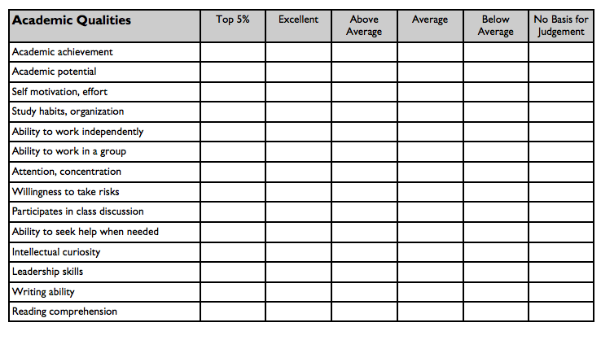
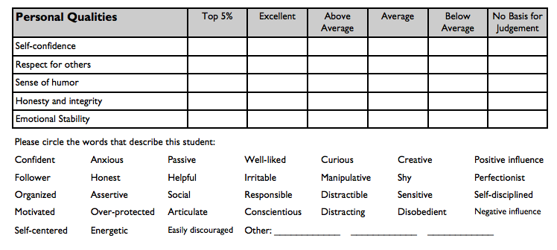

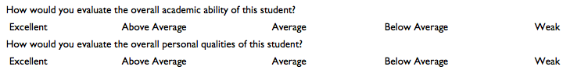

Would you have any concerns in taking this student on an overnight field trip or question their ability to represent Karr during a field trip? (E-mail Ms. Lu if this is the case)
Teacher Evaluation #2

Student Name:________________________

Teacher: _____________________________

Would you have any concerns in taking this student on an overnight field trip or question their ability to represent Karr during a field trip? (E-mail Ms. Lu if this is the case)

Parent Consent Form

Dear Parent,

Your child is applying to take part in a Spring Break Trip with Edna Karr to visit colleges and universities in the Midwest

By signing below you signify that you have done and agree the following things

- I have read through the trip information sheet and understand the purpose of the trip.
- I understand what criteria will be used to evaluate my child when participants are being chosen for the trip.
- I know that if my child if chosen for the trip I will be responsible for at least $450 in expenses.
- My child is available during the dates of the trip (Sunday, March 29th - Saturday, April 4th 2015)
- I understand that my child will be responsible for maintaining good academic and behavioral standing before the trip. If they are to lose that standing they can be removed from the trip’s participant list and the financial contributions I have made to the trip will be lost.

_____________________________________________ ___________________________
Parent Signature Date

__________________________________________
Student Name

